SCUBA-2 Block Specification
wbs_fb_data

Revision History:
Rev. 1.0 MN Initial Release
Rev. 1.1 MA added document number and revision history

September 15, 2006
Table of Contents

1. Block Overview 3
1.1 Block Location and Block Interface within System 3
1.2 Block Functionality / Features 3
1.3 Block Dataflow 4
1.3.1 Top Level Dataflow 4
1.3.2 The p_banks_admin Dataflow 5
1.3.3 The misc_banks_admin Dataflow 5
2. Block Interfaces 7
2.1 Interface Signal Description 7
2.2 Interface Protocol and Timing 9
3. High-Level Description 10
3.1 Timing Description 10
3.2 Special Optimizations 12
4. Files of the Block 13
4.1 Source Code 13
4.1.1 Source1.vhd 13
4.2 Header Code 13
4.2.1 Header1.vhd 13
5. Naming Conventions Used 14

Block Overview

Block Location and Block Interface within System
The wbs_fb_data is located on the Readout card FPGA. It is a wishbone slave and it interfaces with the following blocks:
- Dispatch (wishbone master);
- The flux_loop_ctrl (8 instances).

wbs_fb_data
flux_loop_ctrl
flux_loop_ctrl
flux_loop_ctrl
flux_loop_ctrl
flux_loop_ctrl
flux_loop_ctrl
flux_loop_ctrl
flux_loop_ctrl
dispatch
Figure 1: Location of wbs_fb_data in the Readout card FPGA.

Block Functionality / Features
The wbs_fb_data is a wishbone slave and has to be able to process wishbone read and write instructions. Moreover, it provides data to flux_loop_ctrl blocks. The wbs_fb_data receives data for the following parameters from the dispatch and provides them to the downstream block: P/I/D/Z, adc_offset, filter_coeff, servo_mode, ramp_step_size, ramp_amp, const_val, num_ramp_frame_cycles, sa_bias, and offset_dat. The wbs_fb_data will also provide the data stored for these parameters to the dispatch upon the dispatch read request.
Data for P/I/D/Z, and adc_offset are stored in RAM blocks. However, the data for the rest of the parameters are stored in registers.

Block Dataflow
To manage the complexity, wbs_fb_data uses five identical memory bank administrator (p-banks_admin, i_banks_admin, d_banks_admin, z_bank_admin, and adc_sample_banks_admin) and one miscellaneous memory bank administrator for the remaining parameters.

Top Level Dataflow
Figure 2 represents a top level view of the dataflow in wbs_fb_data.

From Dispatch
adc_sample_banks_admin
addr_i
misc_banks_admin
p_banks_admin
d_banks_admin
z_banks_admin
i_banks_admin
To
flux_loop_ctrl blocks
To Dispatch
Figure 2: The wbs_fb_data block dataflow.

The p_banks_admin Dataflow
Figure 3 illustrates the dataflow in the p_banks_admin block. As mentioned earlier, the memory bank administrators for I/D/Z and adc_sample parameters are identical to the p_banks_admin block.

wbs_fb_storage
ch0
wbs_fb_storage
ch1
wbs_fb_storage
ch2
wbs_fb_storage
ch3
wbs_fb_storage
ch4
wbs_fb_storage
ch5
wbs_fb_storage
ch6
wbs_fb_storage
ch7
From Dispatch
addr_i
To
Respective
flux_loop_ctrl
block
To
Parent Block
Figure 3: The p-banks_admin dataflow.

The misc_banks_admin Dataflow
The misc_banks_admin block instantiates several registers for the following parameters:
- filter_coeff (seven values in total);
- servo_mode;
- ramp_step_size;
- ramp_amp;
- const_val;
- num_ramp_frame_cycles;
- sa_bias_dat (one for each channel);
- offset_dat (one for each channel).

The dataflow of misc_banks_admin is illustrated in Figure 4 where the block numbers correspond to the following indices:
- Block number 0-6 for filter_coeff
- Block number 7 for servo_mode;
- Block number 8 for ramp_step_size;
- Block number 9 for ramp_amp;
- Block number 10 for const_val;
- Block number 11 for num_ramp_frame_cycles;
- Block number 12-19 for sa_bias_dat;
- Block number 20-27 for offset_dat.

0
..
6
7
8
9
10
11
12
..
19
20
..
27
tga_i
addr_i
To
Parent Block
To All
flux_loop_ctrl
To All
flux_loop_ctrl
To
Respective
flux_loop_ctrl
block
From Dispatch
tga_i
Figure 4: The misc_banks_admin dataflow.

Block Interfaces

Interface Signal Description
- Interface Signals
Signal | Description | Direction
Global Signals
clk_50_i | Global clock | in
rst_i | Global reset | in
Per flux_loop_ctrl channel (# must be replaced by 0 to 7)
adc_offset_dat_ch#_o | adc_offset data for flux_loop_ctrl channel 0-7. | out
adc_offset_addr_ch#_i | Read address from flux_loop_ctrl channel 0-7. | in
p_dat_ch#_o | P data for flux_loop_ctrl channel 0-7. | out
p_addr_ch#_i | Read address from flux_loop_ctrl channel 0-7. | in
i_dat_ch#_o | I data for flux_loop_ctrl channel 0-7. | out
i_addr_ch#_i | Read address from flux_loop_ctrl channel 0-7. | in
d_dat_ch#_o | D data for flux_loop_ctrl channel 0-7. | out
d_addr_ch#_i | Read address from flux_loop_ctrl channel 0-7. | in
z_dat_ch3_o | Z data for flux_loop_ctrl channel 0-7. | out
z_addr_ch#_i | Read address from flux_loop_ctrl channel 0-7. | in
sa_bias_ch#_o | sa_bias data for flux_loop_ctrl channel 0-7. | out
offset_dat_ch#_o | offset data for flux_loop_ctrl channel 0-7. | out
All flux_loop_ctrl channels
filter_coeff0_o | First filter coefficient to all flux_loop_ctrl. | out
filter_coeff1_o | Second filter coefficient to all flux_loop_ctrl. | out
filter_coeff2_o | Third filter coefficient to all flux_loop_ctrl. | out
filter_coeff3_o | Fourth filter coefficient to all flux_loop_ctrl. | out
filter_coeff4_o | Fifth filter coefficient to all flux_loop_ctrl. | out
filter_coeff5_o | Sixth filter coefficient to all flux_loop_ctrl. | out
filter_coeff6_o | Seventh filter coefficient to all flux_loop_ctrl. | out
servo_mode_o | servo_mode data for flux_loop_ctrl. | out
ramp_step_size_o | ramp_step_size data for flux_loop_ctrl. | out
ramp_amp_o | ramp_ampl data for flux_loop_ctrl. | out
const_val_o | const_val data for flux_loop_ctrl. | out
num_ramp_frame_cycles_o | num_ramp_frame_cycles data for flux_loop_ctrl. | out
Dispatch Interface
dat_i | Data in from Dispatch | in
addr_i | Address from Dispatch showing the address of memory banks. The addr_i is kept constant during a read or write cycle. | in
tga_i | Address Tag from Dispatch. The tga_i is incremented during a read or write cycle. Therefore, it is used as an index to the location in the memory bank. | in
we_i | Write Enable input from Dispatch. | in
stb_i | Strobe signal from Dispatch. Indicates if an address is valid or not. See Wishbone manual page 54 and 57. | in
cyc_i | Input from Dispatch indicating a read or write cycle is in progress. | in
dat_o | Data out to Dispatch. | out
ack_o | Acknowledge signal to Dispatch on completion of any read or write cycle. | out

Interface Protocol and Timing
The interface protocol with the Dispatch follows that of the Wishbone protocol. In addition, the flux_loop_ctrl blocks can read their data independently from the memory banks in the p/i/d/z/adc_sample_banks_admin. The read cycle for P/I/D/Z and adc_offset parameters is illustrated in Figure 5 for the P parameter as an example. Moreover, the data in the registers of the misc_banks_admin is available to the flux_loop_ctrl blocks as dedicated inputs. Note that the system user is responsible to make sure valid data is present in the wbs_fb_data before the flux_loop_ctrl blocks are reading them.

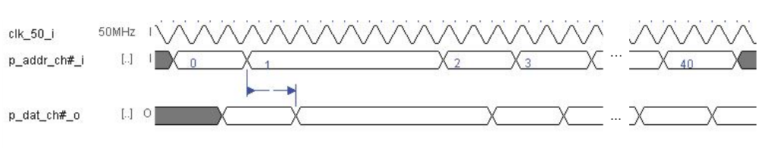
Figure 5: The flux_loop_ctrl read cycle for P/I/D/Z and adc_offset parameter.

High-Level Description

Timing Description
The memory banks administrators work in either of three states: Idle, Wishbone_Read, and Wishbone_Write.
For p_banks_admin, Figure 6 illustrates a write cycle. The same timing also applies to I/D/Z and adc_offset banks administrators, and their operation is identical to that of the p_banks_admin. In Figure 6, following an edge in wren_i, stb_i, and addr_i, data is written into the RAMs where tga_i indicates the location of the memory where the data is stored. An acknowledge signal is hence generated when the data is written into the memory. If the wishbone master asserts a wait by lowering stb_i, the block goes into an idle mode.

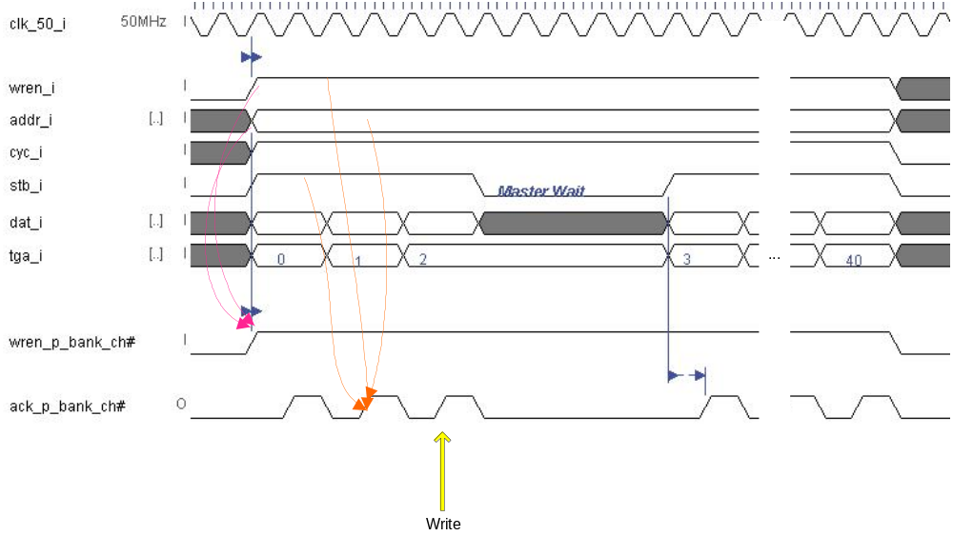
Figure 6: Write cycle for p_banks_admin.

Figure 7 illustrates a read cycle for p_banks_admin. The same timing also applies to I/D/Z and adc_offset banks administrators, and their operation is identical to that of the p_banks_admin. In Figure 7, after two clock cyckes from an edge in wren_i, stb_i, and addr_i, data is read from the RAMs and placed on the dat_o. Two clock cycles delays are needed as the RAM is registered both at the inputs and the outputs. In this read process, tga_i indicates the location of the memory where the data is retrieved. An acknowledge signal is hence generated when the data is read from the memory. If the wishbone master asserts a wait by lowering stb_i, the block goes into an idle mode.

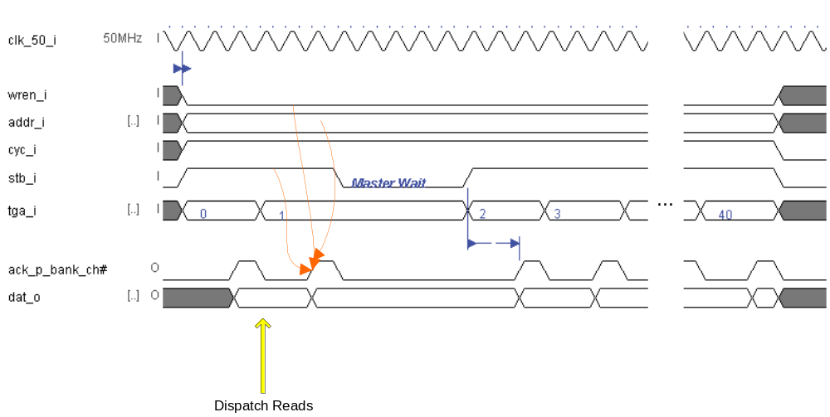
Figure 7: Read cycle for p_banks_admin.

For misc_banks_admin, Figure 8 illustrates a write cycle. This write cycles is shown for parameter sa_bias as an example of a block write. However, it applied to other parameters used in misc_banks_admin. Since a register is used for these parameters, a write cycle is complete in one clock cycle. Therefore, based on the recommendation of the Wishbone manual, the acknowledge signal is the logical AND of stb_i and cyc_i. As seen in Figure 8, appropriate wren signals for each register is generated based on the value of tga_i.

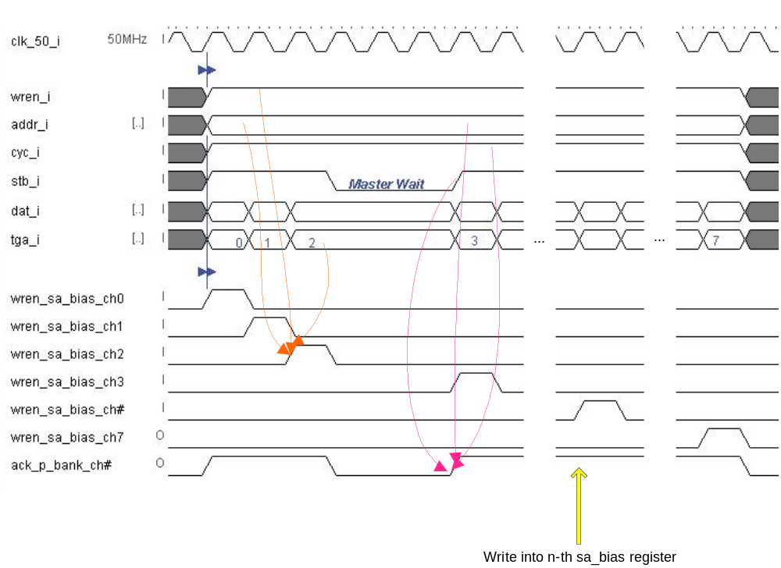
Figure 8: Write cycle for misc_banks_admin.
A read cycle for sa_bias parameter in misc_banks_admin is illustrated in Figure 9. Similarly to the write cycle for misc_banks_admin, the sa_bias read cycle also applies to the read cycle for other parameters in the misc_banks_admin. Since a register is used for these parameters, a read cycle is complete in one clock cycle. Therefore, based on the recommendation of the Wishbone manual, the acknowledge signal is the logical AND of stb_i and cyc_i.

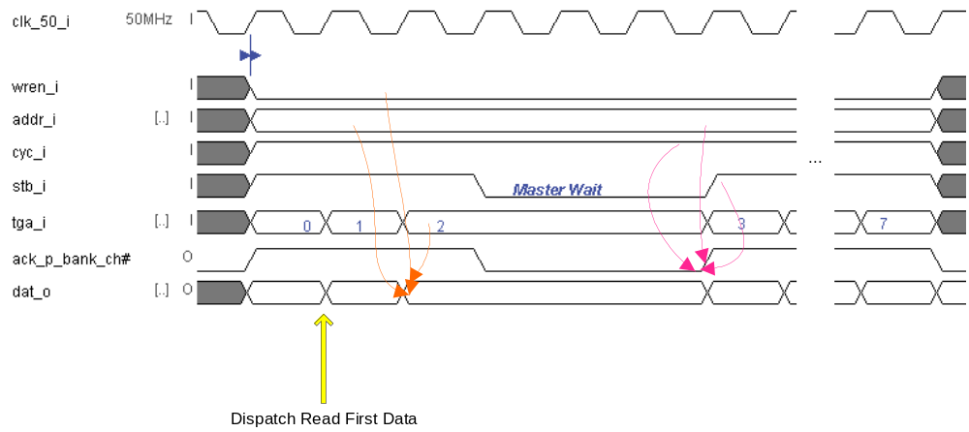
Figure 9: Read cycle for misc_banks_admin.

Special Optimizations

Files of the Block

Source Code

Source1.vhd

Header Code

Header1.vhd

Naming Conventions Used

